[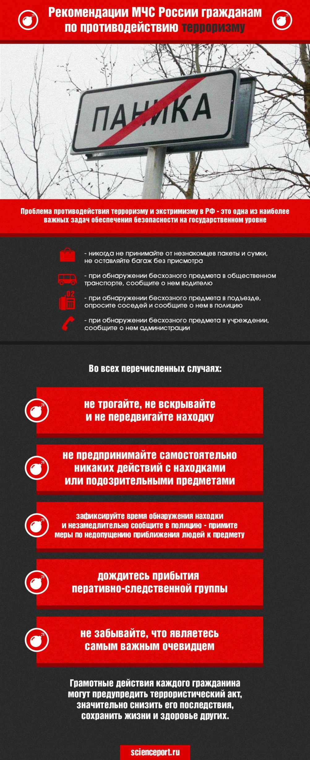](http://imgur.com/my2akko)